Parental Agreement for Daily Screening
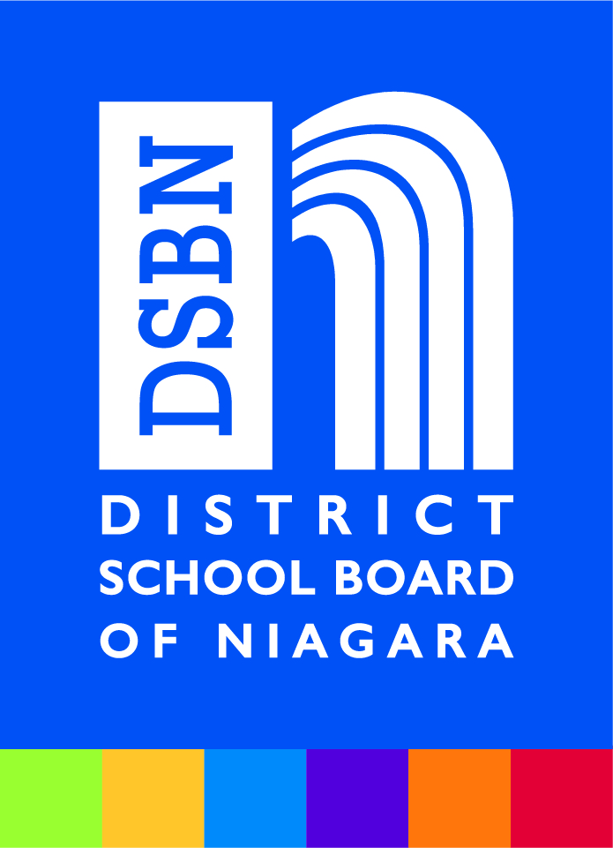

Parent’s Role in Keeping Schools Safe
Everyone has a role to play in keeping families safe and reduce the spread of COVID-19. It is the responsibility of parents and caregivers to assess their children on a daily basis before sending them to school. Additionally, parents must have a person available to pick up their child right away, should they become sick during school. Please read the following guidelines, then sign the agreement below. Further guidance is provided in our Parent Guide and available at www.dsbn.org ‘Return to School’ page.
Guidelines for determining whether a child should remain at home:
Parents and caregivers must assess their child daily for the following symptoms:

- Fever/chills (feeling hot to the touch, a temperature of 37.8 degrees Celsius/100.4 degrees Fahrenheit or higher)
- Cough that's new or worsening (continuous, more than usual)
- Shortness of breath (out of breath even when sitting or walking
- Sore throat (not related to seasonal allergies or other known causes or conditions)
- Runny, stuffy or congested nose (not related to seasonal allergies or other known causes or conditions)
- Unusual level of fatigue
- Headache that’s unusual or long lasting
- Nausea/vomiting, diarrhea, loss of appetite, stomach pain (not related to other known causes or conditions)
- Feeling unwell for an unknown reason
If children display symptoms, they must remain home from school and seek medical attention by a health care provider to see if testing is recommended. Children may return to school when one of the following is met:
- Clearance from their health care provider
- Completion of 14 days of self-isolation and must be symptom free prior to return. This includes children who have symptoms and are recommended for testing but testing is declined.
- Negative COVID-19 test results: child is to remain out of school until 24 hours after their symptoms have resolved
- Positive test result: child has completed the 14 day isolation criteria as directed by Public Health, fever has resolved and child has been consistently improving over the previous 72 hours.
  - NOTE: parents can contact Niagara Region Public Health for general COVID-19 questions at 1-888-505-6074; 905-688-8248, press 7, then press 2.

All students that have travelled outside Canada in the last 14 days, OR were identified by Public Health as a close contact of someone who tested positive for COVID-19 must stay home and self-isolate.

Those unsure of if they, or a student, should self-isolate should be directed to use the Ontario Self-Assessment site.

Parental Agreement
Thank you for your cooperation as we work together to keep everyone safe. Please indicate that you have read and understood the above guidelines by completing the form below. This form must be returned immediately.
□ I have read the above guidelines and agree to assess my child(ren) daily and not send them to school if they are displaying any symptoms listed above.
□ I will ensure that myself or an authorized person is available to pick up my child(ren) immediately should they become symptomatic while at school.

Names of children: ____________________________________________________________________

Name of Parent/Guardian: ______________________________________________________________

Signature of Parent/Guardian: ___________________________________________________________

Date: _________________________________

Personal information and personal health information on this form is collected, used and disclosed in accordance with the Education Act, R.S.O. 1990, c.E.2, as amended, the Municipal Freedom of Information and Protection of Privacy Act. R.S.O 1990, c.M. 56, as amended and the Personal Health Information Protection Act, 2004, c.3 Sched. A., as amended and will be used for the purpose of compliance with Public Health protocols and any similar or related purpose(s). Questions about this collection, use and disclosure should be directed to the Freedom of Information Coordinator, District School of Niagara, 191 Carleton Street, St. Catharines, ON L2R 7P4 905-641-1550.

